Financial Stock Analysis Chatbot AI
Main Thing - A chatbot/web app that helps users to analyze stocks using live market data, charts, and AI-Based responses.

Main Objective of this project -
- Check stock prices
- View charts
- Compare companies
- Ask Finance questions
- Get company details
- Understand stock trends

Practical Uses
- Data Analysis
- Finance domain
- Problem solving
- AI Chatbot logic

Core concepts Involved
- Functions
- Modules
- Error Handling
- Loops
- Condition
- Dictionaries
- DataFrames

Technology stack
- Language - Python
- Libraries - yfinance
- Data Handling - pandas and numpy
- UI - streamlit
- Charts - Plotly and Matplotlib
- AI Chatbot - OpenAI API

Project Folder Structure:
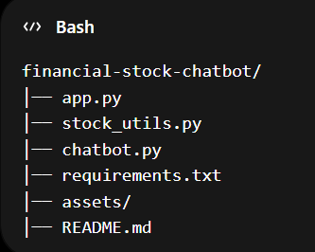

Project Overflow:
Step 1: User enters stock ticker or questions.
Step2: Program identifies the request type, like Price, Chart, Compare and Info.
Step3: Fetch data using API.
Step4: Process data
Step5: Display results in UI.

Testing sites
- AAPL
- TSLA
- MSFT
- RELIANCE.NS
- TCS.NS

What is yfinance?
Ans - yfinance is a library used by Python to get
- Live stock price
- Historical data
- Company Info
- Dividends

What is Streamlit?
Ans - Streamlit helps convert Python scripts into web apps quickly.
It is used for:
- Dashboard
- Charts
- Inputs
- Buttons
- Tables

What is feedparser?
Ans - It reads RSS News feed.

What is textblob?
Ans - A library for natural language processing (NLP). Here, it’s used to analyze sentiment (positive, negative, neutral) of news headlines.

To run this project we have to type - streamlit app.py (in bash)

What is SQLite Database Connection?
Ans - It is a lightweight relational database. It is used for small projects or prototypes.
No separate server is required for this. Stores in a local .db file.
It is used in this project because to store user credentials.

What is a cursor in a database?
A cursor is an object used to interact with the database and run SQL commands.

Why hash passwords are used?
What is SHA-256?
Difference between hashing and encryption?
What is commit in SQL?

Important point
If interviewer asks improvements in the project, then I would say that, in production, I would use bycrypt instead of SHA-256, JWT Tokens, email verification and PostgreSQL.

